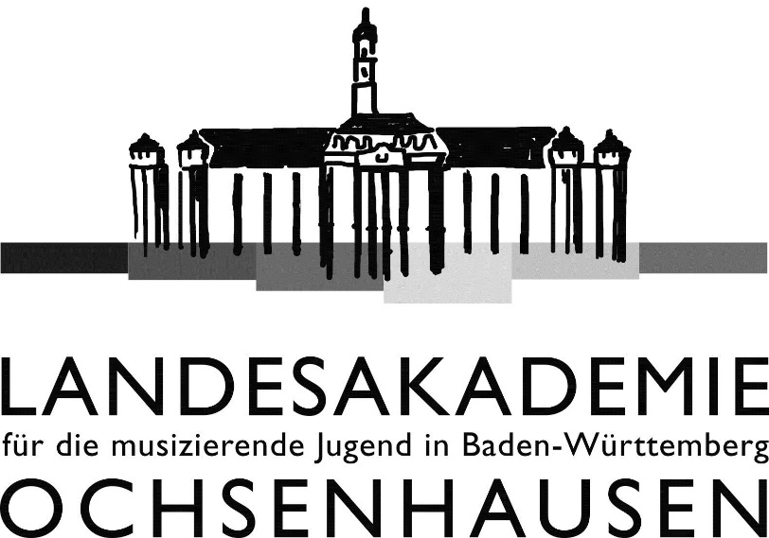

25 Years
C.H.O.I.R.

Under the patronage of
Ministerpräsident Winfried Kretschmann

August 7th to August 18th 2020

State Academy
for Young Musicians in Baden-Wuerttemberg
Ochsenhausen, Germany

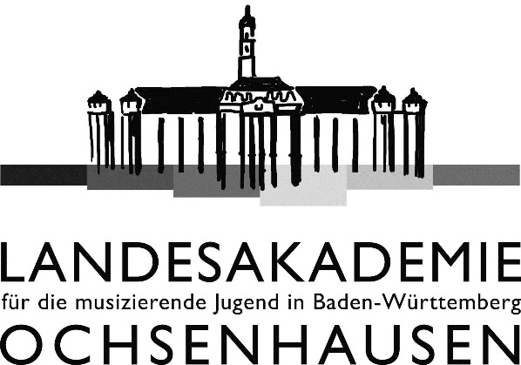

Landesakademie für die musizierende Jugend in Baden-Württemberg
Schlossbezirk 7 • D-88416 Ochsenhausen
Phone +49 7352 9110-0 • Fax +49 7352 9110-16
http://www.landesakademie-ochsenhausen.de
sekretariat@landesakademie-ochsenhausen.de

Interregional youth choir meeting

C.H.O.I.R. 2020

Description
We invite qualified singers (male and female; soprano, alto, tenor, bass) at the age of 17 to 24 to participate in high-level preparation of G. Verdis Messa da Requiem in the State Academy Ochsenhausen. Finally we end up in four concerts in different cities of Baden-Württemberg.
Meanwhile we want to encourage intensive communication besides music among young people of different nationalities through a supporting cultural program.
Additionally we offer a voice training for vocal soloists.

Organizer
Landesakademie für die musizierende Jugend in Baden-Württemberg (State Academy for Young Musicians in Baden-Württemberg).
This festival is supported and sponsored by the Ministry for Science, Research and Art of Baden-Württemberg.

Partner Regions
Baden-Wuerttemberg (GER) – Bosnia and Herzegovina (BIH) - Catalonia (ESP) - Coimbra (POR)
Croatia (CRO) - Emilia-Romagna (ITA) – Estonia (EST)
Flanders (BEL) – Hungary (HUN) - Kanagawa (JPN)
Lodz (POL) - Lombardy (ITA) – Ontario (CAN)
Rhone-Alpes (FRA) - Russian Federation (RUS)
Saxony (GER) - Singapore (SIN) – Slovenia (SLO)
Taiwan (TPE) - Wales (GBR)

Dates and Location
The 25th C.H.O.I.R. festival takes place between 7th and 18th of August 2020 at the Landesakademie für die
musizierende Jugend (State Academy for Young Musicians) in Ochsenhausen.

Concerts
Serenade (musical presentation of the regions):
August 9th in Ochsenhausen

Concerts:
August 13th in Laupheim, August 14th in Stuttgart,
August 16th in Ravensburg and August 17th in Ochsenhausen

Artistic direction

Christine Wetzel, Landesakademie Ochsenhausen
Michael Alber, Stuttgart

Organization
Prof. Dr. Klaus K. Weigele,
director of the Landesakademie
Christine Wetzel, lecturer Landesakademie
Mirjam Knaus, project management

Program

Giuseppe Verdi: Messa da Requiem
Orchestra:
Members of Radiosinfonieorchester Belgrad

Collective Composition-「Ora Pro Pace」
1. Ching-Wen Chao: Dona Nobis Pacem（Taiwan）
2. Jakub Neske: Cantate Domino（Poland ）
3. Vladimir Poljakov: Jubilate Deo（Russia）
4. Shu-Si Chen: Ubi Caritas（Taiwan）
5. Matsushita Ko: Alleluia（Japan）
(world première)
Commissioned by the Landesakademie for C.H.O.I.R. 2020

Information and Enrolment

Enrolment deadline: June 5th, 2020

Landesakademie für die musizierende
Jugend in Baden-Württemberg
Schloßbezirk 7
88416 Ochsenhausen, Germany
Phone: +49 7352 / 9110-0
Fax: +49 7352 / 9110-16
E-Mail: projektbuero@landesakademie-ochsenhausen.de

Conditions
We invite experienced singers at the age of 17 to 24 from Baden-Württemberg and its partner regions.
Each region has 10 accommodations for free. The financial conditions are the following: rooms and meals are free; there will be no extra fees. Travel expenses have to be paid by the participants.
Participants from Baden-Wuerttemberg pay 355,00 €.

If a region would like to send more singers please contact the State Academy Ochsenhausen. Every additional participant will have to pay a fee of 355,00 €.

Interregional youth choir meeting

C.H.O.I.R. 2020

25. Interregionales Jugendchortreffen
vom 07. – 18. August 2020
an der Landesakademie für die musizierende
Jugend in Baden-Württemberg, Ochsenhausen

25th Interregional YOUTH
CHOIR MEETING
August 7th to August 18th 2020
at the State Academy for Young Musicians in Ochsenhausen

25. FESTIVAL INTERREGIONAL DE CHŒURS DE JEUNES
du 7 aôut au 18 aôut 2020
à l’Académie régionale de la jeunes musicienne à Ochsenhausen

25. Festival interregionale
DEI CORI GIOVANILI
al 7 agosto dal 18 agosto 2020
nella Landesakademie (accademia statale) per giovani musicisti a Ochsenhausen

25. Festival interregional
del coro de la juventud
del 7 al 18 de agosto 2020
en la academia federal de música para la juventud en Ochsenhausen

Veranstalter:
Landesakademie für die musizierende Jugend in Baden-Württemberg, gefördert vom Ministerium für Wissenschaft, Forschung und Kunst Baden-Württemberg

Organized by:
State Academy for Young Musicians in Baden-Württemberg, sponsored by the Ministry of science, research and art of Baden Württemberg

Organisateur:
L’Académie régionale de la jeunes musicienne du Baden-Württemberg, encouragé par le Ministère de la science, recherche et art du Baden-Württemberg

Organizzatori:
Landesakademie per giovani musicisti del Baden-Württemberg, promosso dal Ministero della scienza, esplorazione e arte del Baden-Württemberg

Organizador:
Academia federal de música para la juventud en Baden Wurttemberg, patrocinado por el Ministerio de la ciencia, exploración y arte de Baden-Württemberg

